ANDERSON RANCH ARTS CENTER DEBUTS INSIDE MY STUDIO SERIES

SERIES OF SIX INTIMATE IN-STUDIO INTERVIEWS WITH LEADING CONTEMPORARY ARTISTS

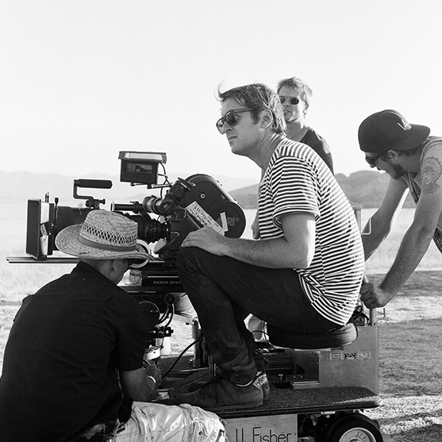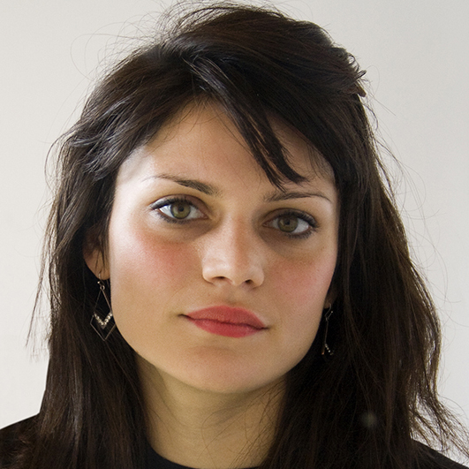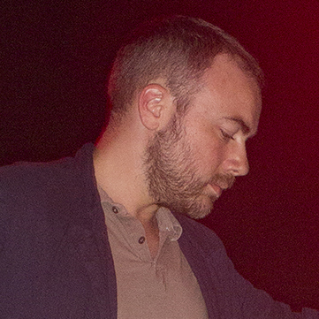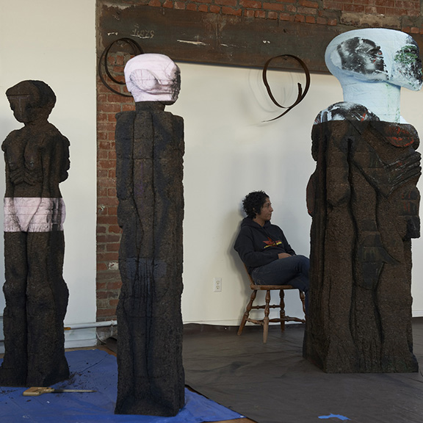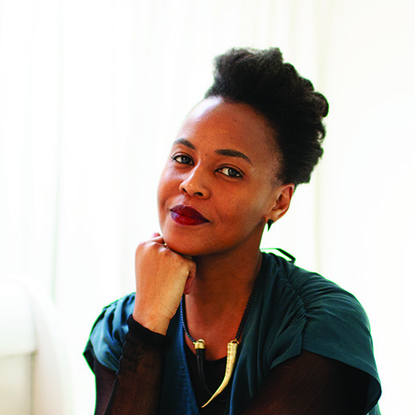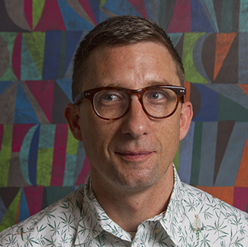
Doug Aitken, Diana Al-Hadid, Walead Beshty, Huma Bhabha, Wangechi Mutu and William J. O'Brien.

Aspen/Snowmass, Colorado (May 15, 2018) — Anderson Ranch Arts Center, a premier destination for art making and critical dialog in the contemporary art world, commissioned filmmaker/art collector Dennis Scholl to produce and direct six short films featuring interviews with world-renowned artists Doug Aitken, Diana Al-Hadid, Walead Beshty, Huma Bhabha, Wangechi Mutu and William J. O'Brien. Each interview was recorded on-site at the Ranch during the summer of 2017, and features artists who have close ties to Anderson Ranch Arts Center through their participation in its workshops, programs and events. The series will be released in a partnership between Anderson Ranch and Cultured magazine.

The series, titled “Inside My Studio”, offers intimate insights into the studio practices of contemporary artists. Interviews are interwoven with footage of artists’ recent activations in the art world, such as Diana Al-Hadid’s Outside/Inside (2017), allowing viewers to understand their work in new and more meaningful ways. Each five to 10-minute film —created for the Anderson Ranch community of artists, students, and friends— dives into the nuts and bolts of these leading artists' studios, revealing everything from the music they listen to while they work to how they find inspiration and achieve success.

“Given the subject matter and insights provided in each video, the ‘Inside My Studio’ series has deep ties to Anderson Ranch’s mission. They promote art making, community and dialog in contemporary arts,” said Nancy Wilhelms, Executive Director of Anderson Ranch Arts Center. Wilhelms continued, “We’re proud to partner with Dennis, a longtime Ranch supporter, on this project and look forward to sharing his work with the world.”

"I've been involved with Anderson Ranch for more than a decade, and I’ve seen firsthand what a special place it is for learning and experimentation,” commented Scholl. “The pressure-free environment of the Ranch’s studios allows artists to learn new disciplines and delve deeper into their own fields of interests, and these films offer a look into that important creative process by showcasing the studio practices of some of the greatest artists of our time."

Support for “Inside My Studio” is generously provided by Lynda and Stewart Resnick.

Each video in the Inside My Studio series will be released weekly, both on Cultured Magazine Online and on the Anderson Ranch YouTube channel.

ABOUT DENNIS SCHOLL
Dennis Scholl is an award-winning documentary filmmaker with a focus in arts and culture. His interview subjects include Robert Redford, Frank Gehry, Wynton Marsalis, Tracey Emin and Theaster Gates. He has won 11 National Academy of Television Arts and Science regional Emmys for documentaries about art and artists and is the executive producer of a dozen films with the Miami-based Borscht Film Collective, including six short films that debuted at the Sundance Film Festival. He and his wife Debra received the National Service to the Arts award from Anderson Ranch Arts Center in 2014.

ABOUT CULTURED MAGAZINE
A destination for discovery, Cultured offers a distinct voice at the intersection of contemporary art, architecture, design and fashion. Cultured speaks to a discerning audience through its compelling interviews, luxurious features and innovative portraits of the personalities shaping the creative world today and is published five times a year.

ABOUT ANDERSON RANCH ARTS CENTER
Founded in 1966, Anderson Ranch Arts Center is a premier destination in America for art making and critical dialog, bringing together aspiring and internationally renowned artists to discuss and further their work in a stimulating environment. Nestled in the Rocky Mountains of Aspen/Snowmass, Colorado, the Ranch hosts more than 140 workshops for aspiring, emerging and established artists in eight disciplines, including Photography & New Media, Ceramics, Painting & Drawing, Furniture Design & Woodworking, Sculpture, Woodturning, Printmaking and Digital Fabrication as well as year-round public events and art auctions whose proceeds directly benefit Anderson Ranch educational programs. For more than 50 years Anderson Ranch Arts Center has been working to enrich lives with art, inspiration and community. Learn more at www.andersonranch.org or 970/923.3181.

Join the conversation on social media by mentioning Anderson Ranch Arts Center and using the hashtag #AndersonRanch when posting.

# # #

Follow us on Facebook | Twitter | Instagram
Visit us at http://www.andersonranch.org

MEDIA CONTACT:

PR Representatives, FITZ & CO:
Meg Huckaby | mhuckaby@fitzandco.art | 646/589.0928
Simon Guy Warren | swarren@fitzandco.art | 646/589.0922

